**What is linked list ?**

Linked list is an linear data structure, which consists of a group of nodes in a sequence **[OR]** Linked list in which we store data in linear from!

*But, Array also stores data in linear form.* Then what's the difference!

In array we have to first define the size of the Array  
Let's say:-

int arr[] = new int[8]

Array :- [10, 20, 15, 18, 16, 10, 20, 16]

And each bit has it's *memory address*, where 1 bit size = 4, therefore 8 bit = 8 * 4 = 32 bit.

But linked list is dynamic, we don't have to define it's size.

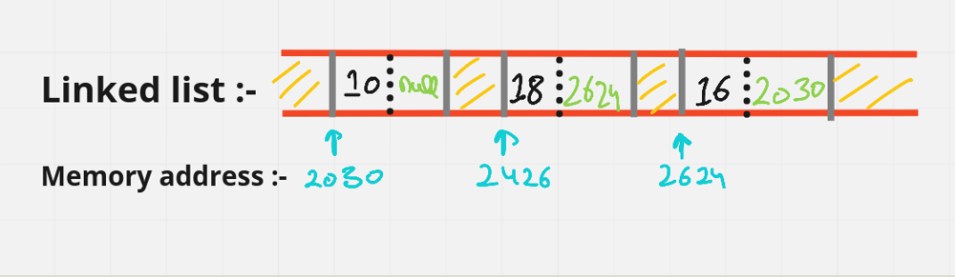

*In linked list we can add element as many as we want. But, in array size is fixed. So, to add new element we have to create a new array!*

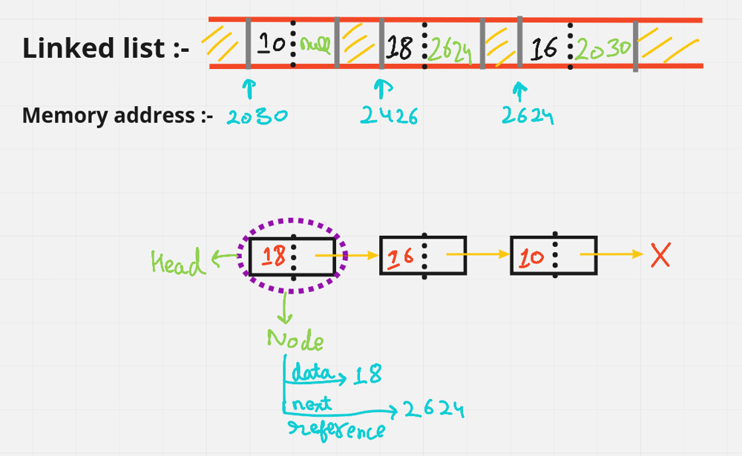

Advantages DisAdvantages

1. Dynamic Nature 1. More memory usage due to address pointer

2. Optimal insertion & deletion 2. Slow traversal compared to arrays

3. Stack's & queues can be easily implemented 3. No reverse traversal in singly linked list

4. No memory wastage 4. No random access

**Real-life Application's :-**

* Previous - n - next page in browser
* Image Viewer
* Music Player